School of Computer Science and Artificial Intelligence

Lab Assignment # 13.2

Program : B. Tech (CSE)
Specialization : -
Course Title : AI Assisted Coding
Course Code : 23CS002PC304
Semester : II
Academic Session : 2025-2026
Name of Student : J.Harshith yadav
Enrollment No. : 2403A51L49
Batch No. : 52
Date : 10/03/26

Submission Starts here

Screenshots:

Task Description -1 (Refactoring – Eliminating Repetitive Logic)

Prompt:
Refactor the following Python program to eliminate repetitive logic.

Requirements:
1. Identify repeated calculations in the code.
2. Encapsulate the repeated logic into a reusable function.
3. The function should compute both area and perimeter of a rectangle.
4. Ensure the output remains exactly the same as the original program.
5. Add proper Python docstrings to the function explaining parameters and return values.
6. Keep the code clean, readable, and maintainable.

Here is the original code:

length = 8
width = 4
print("Area:", length * width)
print("Perimeter:", 2 * (length + width))

length = 12
width = 6
print("Area:", length * width)
print("Perimeter:", 2 * (length + width))

Output:
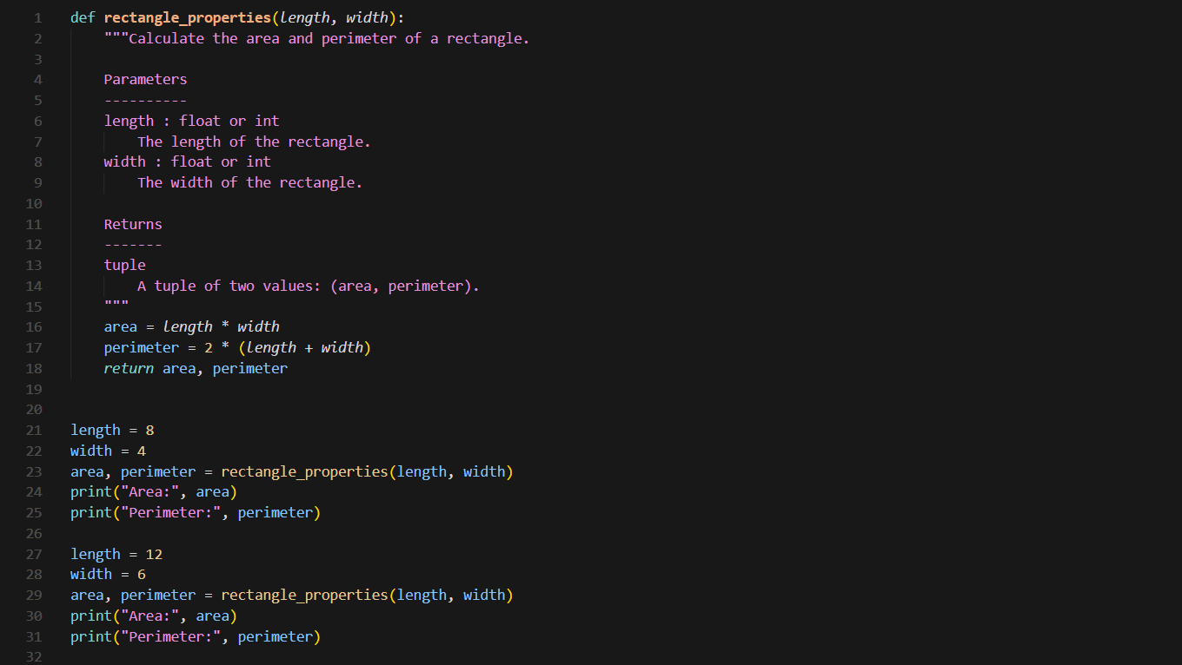

Task Description -2 (Refactoring – Modularizing Inline Calculations)

Prompt:

Refactor the following Python code by extracting repeated inline calculations into a reusable function.

Requirements:
1. Detect repeated calculation patterns.
2. Create a reusable function to compute the final amount after applying discount.
3. Add a clear docstring explaining the function purpose, parameters, and return value.
4. Ensure the final output remains the same as the original program.
5. Improve readability and modularity.

Original Code:

amount = 1000
discount = amount * 0.10
final_amount = amount - discount
print("Final Amount:", final_amount)

amount = 2000
discount = amount * 0.10
final_amount = amount - discount
print("Final Amount:", final_amount)

Output:
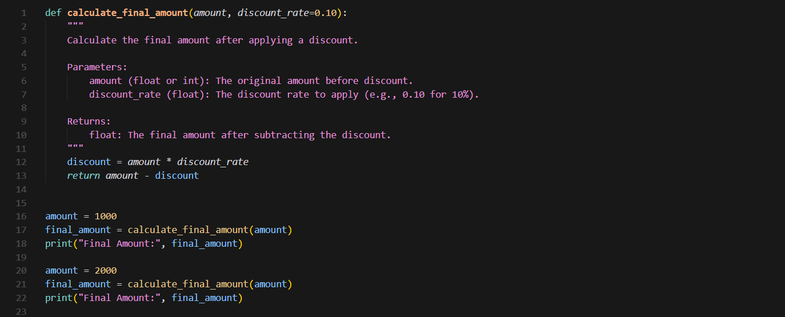

Task Description -3 (Refactoring – Improving Loop and Conditional Performance)

Prompt:

Optimize the following Python program to improve performance.

Requirements:
1. Identify inefficient nested loops and repeated conditional checks.
2. Replace the inefficient lookup logic with a more efficient data structure such as a set.
3. Maintain the same program output.
4. Provide both the original and optimized versions.
5. Measure and compare execution time of both versions using the time module.
6. Add comments explaining the optimization.

Original Code:

students = ["Anil", "Bhavya", "Charan", "Divya"]
check_list = ["Charan", "Esha", "Bhavya"]

for name in check_list:
exists = False
for student in students:
if name == student:
exists = True

if exists:
print(name, "found")
else:
print(name, "not found")

Output:
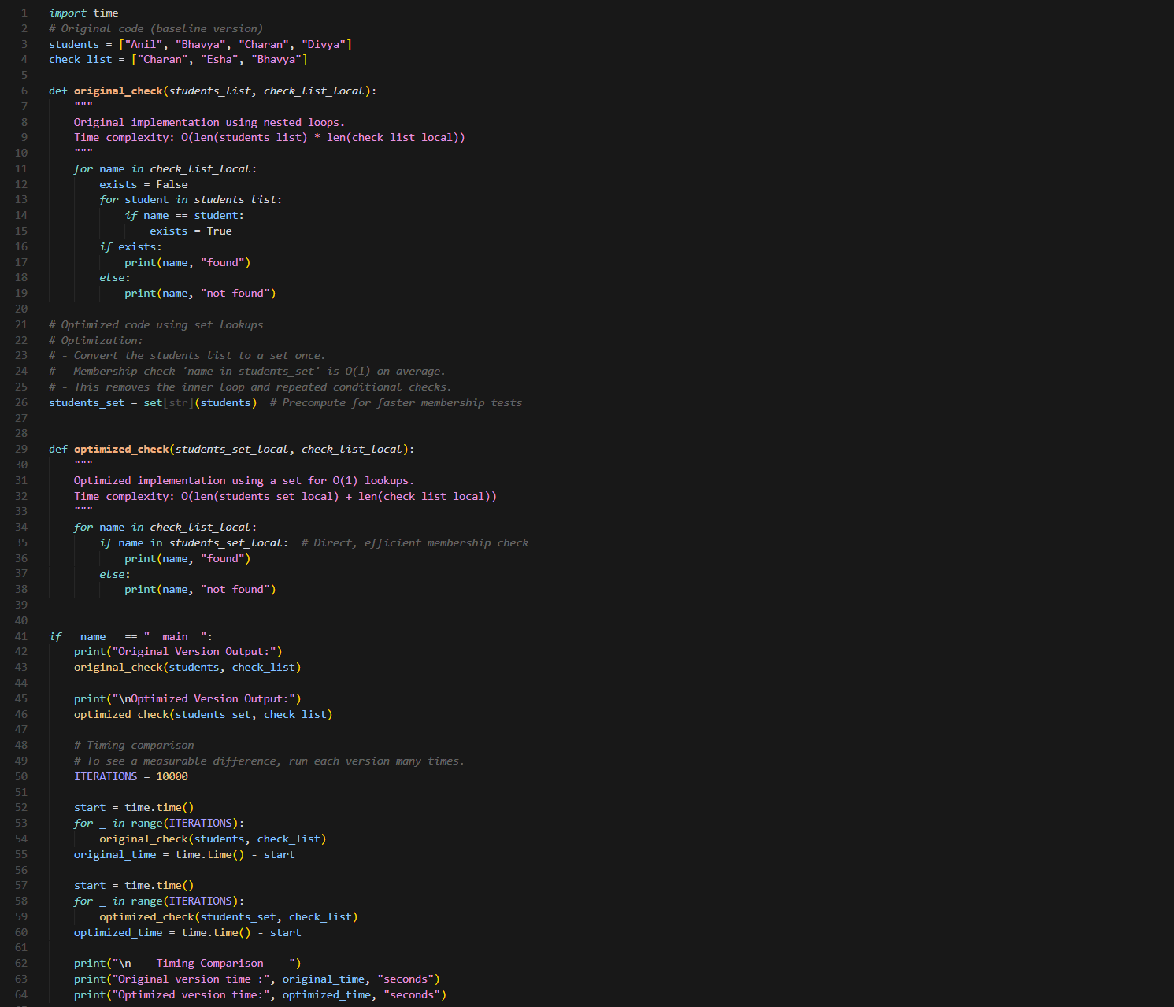

Task Description -4 (Refactoring – Replacing Hardcoded Values with Constants)

Prompt:

Refactor the following Python code to replace hardcoded numeric values with named constants.
Requirements:
1. Identify all hardcoded numeric values.
2. Create descriptive constants at the top of the program.
3. Use constant names like RATE and TIME instead of raw values.
4. Ensure the program output remains unchanged.
5. Improve code readability and maintainability.
6. Add comments explaining the constants.

Original Code:

print("Simple Interest:", (1000 * 2 * 5) / 100)
print("Simple Interest:", (2000 * 2 * 5) / 100)

Output:
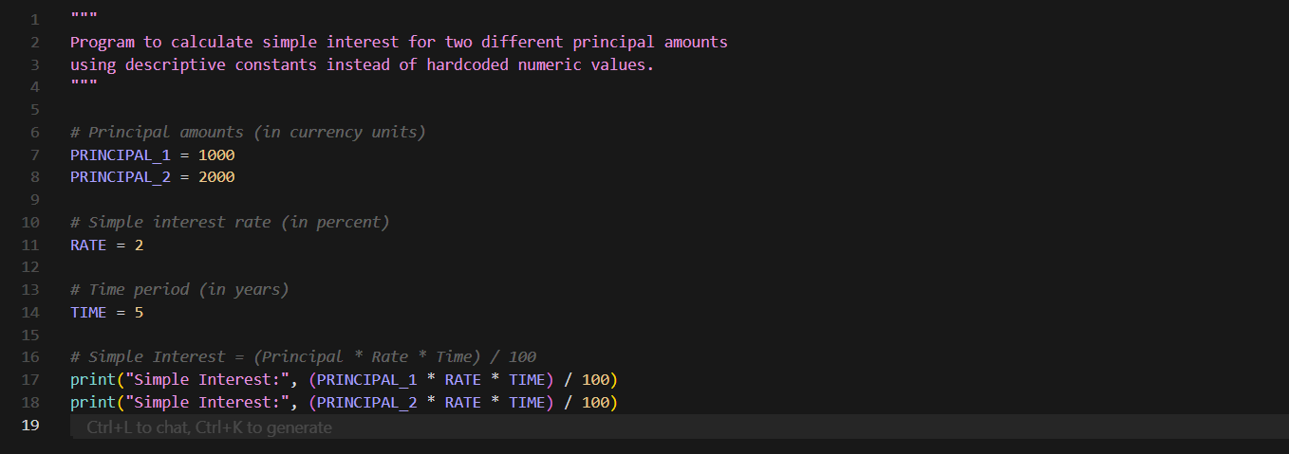

Task Description -5 (Re factoring – Enhancing Variable Naming and Code Clarity)

Prompt:

Improve the readability of the following Python program.

Requirements:
1. Replace unclear variable names with meaningful descriptive names.
2. Add inline comments explaining the logic.
3. Ensure the program output remains exactly the same.
4. Follow Python naming conventions.
5. Make the code easier to understand for beginners.

Original Code:

x = 50
y = 30
z = x + y
print(z)

Output:
